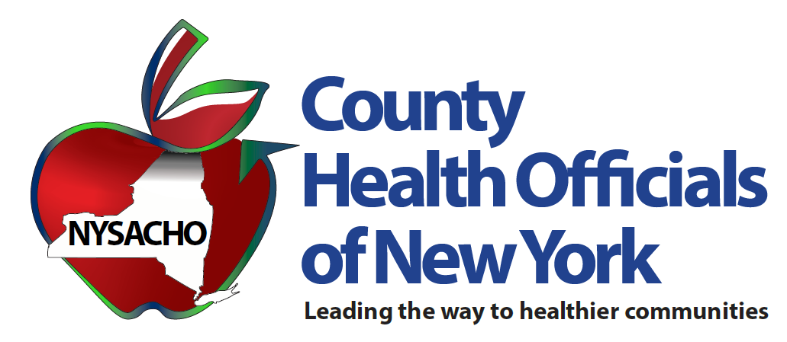

Lead Poisoning Prevention:

**Funding the Expanded Mandate to Protect the Children of New York State**

[INSERT PHOTO]

*“New York State has proven time and again it is committed to safeguarding its children, and have shown that its legislature and the governor, representing all of New York,   
take action based on scientific research”*

Contact: Sarah Ravenhall, MHA, CHES

Executive Director

New York State Association of County Health Officials

One United Way, Albany NY 12205

sarah@nysacho.org

518-456-7905 x108

**Table of Contents**

1.1 Who are we? 3

1.2 What do Local Health Departments do and how do they do it? 3

2.1 The Expanded Mandate 5

2.2 Why do we need to worry about lead? 5

2.3 What are the sources of lead that make children sick? 6

2.4 Why does lead-based paint affect New York particularly? 6

2.5 Why are children at higher risk? 6

2.6 Roles and responsibilities of Local health departments 6

3.1 Proposed funding options 8

3.2 Utilizing Health Care Reform Act (HCRA) Resources 9

3.3 Utilizing General Fund resources 9

3.4 Introducing a lead poisoning prevention fee on paint 10

3.5 Surcharge fee on homeowner’s insurance and renter’s insurance 11

3.6 Utilizing master settlement agreement (MSA) funds for secondary and

tertiary prevention 12

3.7 Creation of the New York State lead abatement program 13

3.8 Residential property lead-based paint hazard abatement revolving loan fund 14

3.9 Lead-safe housing registry as a resource to renters 15

3.10 Regulation of online rental marketplace listings 16

4.1 References 17

**1.1 Who are we?**

New York State Association of County Health Officials, NYSACHO, represents the collective voice of local health departments in New York State. NYSACHO supports, advocates for, and empowers local health departments in their work to promote health and wellness, to prevent disease, disability and injury throughout New York State.

While NYSACHO commends the state legislature for decreasing the definition of Elevated Blood Lead Level, thereby ensuring more children are protected from the adverse effects of lead,   
Local health departments across New York State are facing challenges in implementing the expanded mandate put forth by the state.

**1.2 What do Local Health Departments do and how do they do it?**

Local health departments (LHDs) are at the forefront of New York State’s public health issues, serving as the first line of defense against all new and potentially widespread public health crises.

LHDs are agencies of county governments that work closely with the New York State Department of Health (DOH). Local health departments are organized under the statutory authority of Article 3 of the Public Health Law (PHL). Article 6 of PHL is the primary statutory mechanism through which the state reimburses core public health services provided by local health departments. Local health departments also are responsible for the enforcement and delivery of services related to many other areas of public health law.

Through our LHDs, counties provide essential, population-based health services that promote and protect the health of all who live, work, and play in counties throughout New York. County LHDs protect the public’s health by:

• Developing and maintaining individual and community preparedness for public health hazards and events;

• Investigating, preventing, and controlling communicable diseases;

• Preventing environmental health hazards through assessment, regulation, and remediation;

• Preventing chronic diseases through outreach and education to promote healthy lifestyles; and

* Providing services to individuals, children, and families that have developmental delays and concerns.

This paper provides:

1. An overview of the important role of Local Health Departments in protecting public health,

2. A synopsis of the impact of lowering the definition of Elevated Blood Lead (BLL) to 5 micrograms per deciliter

3. An outline of NYSACHO’s proposal of funding options for the expanded mandate

**2.1 The Expanded Mandate**

During the 2019 legislative session, New York State passed into law a bill lowering the level of lead in a child’s blood requiring action under the Childhood Lead Poisoning Prevention Program from 10 micrograms of lead per deciliter (mcg/dL) of whole blood to 5 mcg/dL following the level set by the CDC in 2012.

New York State has proven time and again it is committed to safeguarding its children, and have shown that its legislature and the governor, representing all of New York, take action based on scientific research.

New York State Department of Health estimates that the lowering of the blood lead level (BLL) will result in an estimated 17,046 additional cases, which is a six-fold increase from current statistics. The states investment of $9.4 million for local health departments, by Article 6 funding, leaves approximately $36.6 million or 80% of the costs to be paid by local governments.

A survey conducted by NYSACHO of Local health Departments regarding the budget impact and resource needs related to the statute identified additional personnel costs including nursing and environmental health staff, health educators, clerical/support staff and staff recruitment and training costs. Non personal expenses noted in the survey included lab-testing, equipment (XRF machine, desks, file cabinets, computer etc.), additional workspace and supplies including dust wipes and cleaning supplies to assist families.

Additionally, reimbursement under Article 6 of the Public Health Law does not cover fringe benefits and indirect costs. Therefore, it is imperative, in order to support the implementation, these additional costs be covered in full by the state through a grant mechanism to allow the needed flexibility to hire at the discretion of the Local health Departments.

**2.2 Why do we need to worry about lead?**

Lead is toxic heavy metal that affects multiple body systems and is particularly harmful to young children [1]. Lead in the body is distributed to the brain, liver, kidney and bones and is stored in teeth and bones where it accumulates over time [1]. According to the World Health Organization (WHO) and Centers for Disease Control and Prevention (CDC), there is no known level of lead exposure that is considered safe [1][3]. Even low levels of lead in blood have been shown to affect IQ, the ability to pay attention and academic achievement and the effect of lead exposure cannot be corrected [3].

**2.3 What are the sources of lead that make children sick?**

Sources of lead include paint (in older homes, old toys, furniture and crafts), dust, soil, drinking water, air, folk medicine and numerous others [2]. However, according to the New York State Department of Health, the most common cause of lead poisoning is dust and chips from old paint [2]. Even though lead-based paints were banned for use in housing in 1978, all houses built prior to 1978 are likely to contain some lead-based paint [3].

**2.4 Why does lead-based paint affect New York particularly?**

According to the United States Census Bureau’s Population Estimates Program, 78% of housing structures in New York State were built prior to 1979 [5] and 42.9% of total housing units were built before 1950 [6]. Given lead-based paints were only banned in 1978, it can be estimated that more than three quarters of all housing units in New York State have lead paint.

**2.5 Why are children at higher risk?**

Children under the age of 6 years are at risk because they are growing rapidly and because they tend to put their hands or other objects, which may be contaminated with lead dust into their mouths [3]. Children living at or below the poverty line who live in older housing are at the greatest risk and additionally; children of some racial and ethnic groups living in older housing are disproportionately affected by lead.

**2.6 Roles and Responsibilities of Local Health Departments**

The roles and responsibilities of local health departments (LHDs) regarding identification and coordination of follow-up services for children with elevated blood lead levels (EBLLs) are defined in NYCRR Title 10 Subpart 67-1 [4]. As defined in 67-1.6, local health departments shall:

* Provide blood lead screening or arrange for blood lead screening for each child who requires screening and whose parent or guardian is unable to obtain a lead test for their child because the child is uninsured, or the child's insurance does not cover lead screening [4].
* Establish a sliding fee schedule for blood lead screening of children from families with incomes in excess of 200% of the federal poverty level, pursuant to Section 606 of the Public Health Law, and collect fees for blood lead testing from third party payers, when available [4].
* Provide environmental management for children with confirmed blood lead levels (BLLs) > 15 mcg/dL. (Note: On May 6, 2009, the NYS Code of Rule and Regulations Part 67-1 was revised to lower the blood lead level requiring environmental management and other specified follow-up services from 20 to 15 mcg/dL, and to clarify that follow-up services are required for all children aged birth to 18 years with elevated blood lead levels. These changes became effective on June 20, 2009.) [4].
* Provide data to identify exposure patterns and high-risk populations for strategic planning for lead poisoning prevention at the state and local levels [4].
* Institute measures to identify and track children with elevated blood lead levels (EBLLs) to assure appropriate follow-up [4].
* Local health departments who serve as a child's primary health care provider shall carry out activities in accordance with paragraphs (1) through (9) of section 67-1.2(a). (See Appendix C, D, E) [4].

LHD lead programs are responsible for tracking all children with BLLs > 5 mcg/dL to assure that appropriate follow-up services are provided [4]. Current New York State regulations define “follow-up” as actions by LHDs and health care providers which, depending on the child’s blood lead level and exposure history, include as appropriate [4].

* Confirmatory and follow-up blood lead testing;
* Risk reduction education;
* Nutritional counseling;
* Diagnostic evaluation which includes a detailed lead exposure assessment, a nutritional assessment including iron status, and developmental screening;
* Medical treatment, if necessary;
* Environmental management; and
* Case management.

To meet their responsibilities, LHD lead programs work in coordination with other team members, who may include the child’s parent(s) or guardian(s), the child’s health care provider(s), other LHD program staff and LHD or NYSDOH District Office (DO) environmental health staff, and other health professionals as needed [4].

**3.1 Proposed funding options to fund current expanded mandate**

A. Funding Mechanism

Lead Poisoning Prevention Activities delivered by local health departments are supported through a variety of funding mechanisms, including the Lead Poisoning Prevention Program, Childhood Lead Poisoning Primary Prevention Program (15 counties), Healthy Neighborhood Program (some counties), and reimbursement through Article Six Public Health Law General Public Health Work funding. When the definition of elevated blood lead level was lowered to 5 ug/dL or greater, the state also allocated an additional $9.7 million to Article Six state aid. This investment falls short of the funding needed and also places the majority of the cost burden on the local tax levy, including 100% of fringe costs associated with any new staff hired to provide public health interventions and case management for the additional children requiring services.

We recommend that all monies allocated for funding the expanded mandate be appropriated into the Lead Poisoning Prevention program of the New York State Department of Health. We further recommend that this funding then be distributed to the local health departments through existing grant mechanisms to support implementation the expanded mandate. Allocating new investments to support the lower EBLL through this program will allow local health departments to secure the necessary staffing and other resources required accomplish the goals set forth by the state mandate, whilst ensuring that New York State keeps its promise to property taxpayers through its enactment of a permanent property tax cap.

B. Funding Options

After consulting with local health departments and other stakeholders, NYSACHO would like to present the following options that could be directed to fund the lower blood lead level mandate of 5 ug/dL, to ensure the vision of the legislature and governor to protect children from lead poisoning is realized and the long-term outcomes of this expanded mandate reach fruition. Recommendations for consideration include:

1. Utilizing Health Care Reform Act (HCRA) Resources
2. Utilizing General Fund resources
3. Introducing a lead poisoning prevention fee on paint
4. Surcharge fee on homeowner’s insurance and renter’s insurance
5. Utilizing Master Settlement Agreement (MSA) funds for secondary and tertiary prevention
6. Creation of the New York State lead abatement program

**Funding proposals for Primary lead poisoning prevention**

* Residential property lead-based paint hazard abatement revolving loan fund (as proposed in New York State Assembly Bill 3432)

**Strategies for primary, secondary and tertiary lead poisoning prevention that don’t require significant fiscal investment**

* Lead-safe housing registry as a resource to Renters
* Regulation of online rental marketplace listings

**3.2 Utilizing Health Care Reform Act (HCRA) Resources**

The New York Health Care Reform Act of 2000 (HCRA 2000), signed into law at the end of 1999, created a new framework for health care finance in New York State. By extending and expanding legislation enacted in 1996, HCRA 2000 addresses a broad range of issues, including mechanisms for hospital reimbursement, graduate medical education finance, and subsidies for care provided to the uninsured [20]. The new legislation enacts a number of major changes to increase funding for health care and attempts to increase access to health insurance [20].

As per the Senate-Assembly Budget bill of 2019, among the appropriations made, HCRA resources funding has been allocated for Children's Health Insurance Account (p.359), Elderly Pharmaceutical Insurance Coverage Program Account(p.359), New York State of Health Account (p.386), Medicaid Fraud Hotline and Medicaid Administration (p.389), Emergency Medical Services Account (p.392), Health Care Delivery Administration Account (p.393), Health Occupation Development and Workplace Demo Account (p.394), Primary Care Initiatives Account (p.395), Cigarette Strike Task Force Account (p.654) and Tobacco Control and Cancer Services Account (p.349) [21].

HCRA resources have been appropriated for public health, health care coverage, and primary health initiatives. Given the significant annual and life-time costs to the taxpayers from children with elevated blood lead levels, we recommend that the state consider investing HCRA resources to fund the expanded mandate.

**3.3 Utilizing General Fund resources**

The general fund is the major operating fund of the State, comprised of all income not earmarked for a particular program or activity and not specified by law to be deposited in another fund. State income for Financial Plan purposes consists of moneys (taxes, fees, and miscellaneous receipts including certain repayments of State advances) deposited to the credit of the General Fund during the fiscal year and transfers from other funds from current revenues [22].

The Enacted Budget Financial Plan Summary for FY 2020 states that the General Fund receipts, including transfers from other funds, are expected to total $77.1 billion[23].

We recommend that the state consider allocating additional General Fund resources to the Lead Poisoning Prevention Program, to be disbursed to local health departments to support the expanded EBLL mandate.

**3.4 Introducing a Lead Poisoning Prevention Fee on Paint**

We propose the NYS Senate and Assembly introduce and pass into law a ‘Lead Poisoning Prevention Fee’ that will act as a per-gallon fee imposed on the sale of paint in New York State and have the revenue collected from the fee be deposited in the Lead Poisoning Prevention Program budget that can be disbursed to Local Health Departments to help fund the expanded mandate.

A similar fee has been imposed in Maine since 2006, and the fee is imposed on the manufacturer or wholesaler level in the amount of 25 cents per gallon of paint estimates to have been sold in the state during the prior year [7][8]. The following recommendations related to the Lead Poisoning Prevention Fee are listed based on a review of literature including legislation related to the fee imposed in Maine.

Lead Poisoning Prevention Fee

1. The fee will be imposed on companies owning the brand name or private label of paint sold in New York State. If paint is imported for sale in New York State, the fee will be imposed on the importer.
2. At the discretion of the New York State legislature, the fee can be waved for smaller companies that sell less than a certain amount of paint per year (in Maine, the fee was waved for companies which sold less than 1,800 gallons a paint in a calendar year).
3. The paint subject to the fee should include architectural coatings (interior and exterior paint, primers, stains and lacquers), product finishes for equipment manufacturers (vehicles appliances, metals and furniture) and special-purpose coatings (traffic marking paint and vehicle refinishing paints) [7].
4. New York residents purchase over 39 million gallons of paint each year [8]. We recommend a paint fee per gallon, which would raise revenues, which would be used to fund the extra workload that falls on Local Health Departments in New York State. We encourage the manufacturers to bear this fee and not charge it to the consumer.
5. We recommend the fee collected be deposited in the Lead Poisoning Prevention Program budget that can be disbursed to Local Health Departments to help fund the expanded mandate. We encourage this to be deemed as grant funding to give flexibility to Local Health Departments to utilize funds for additional personnel hiring and associated fringe benefits.

|  |  |
| --- | --- |
| **Paint fee per gallon** | **Revenue** |
| $0.50 | $19,500,000 |
| $0.75 | $29,250,000 |
| $1 | $39,000,000 |

If the ‘Lead poisoning prevention fee on paint’ was set at $0.50 per gallon, the revenue raised will amount to approximately $19,500,000 per year. If the fee was $1 per gallon of paint, the revenue from the fee will amount to approximately $39,000,000.

If the fee is set at less than $1 per gallon of paint, we propose the legislature and governor utilize any of our other proposed funding options to help fund the balance amount that is required to help fund the existing expanded mandate.

**3.5 Surcharge fee on Homeowners’ Insurance and Renters’ Insurance**

Another recommendation we are making is adding a $25 per year surcharge on homeowners’ insurance and $10 per year surcharge on renters’ insurance for housing units built prior to 1979.

Of the 3.9 million owner-occupied units in New York State, 61.9% of housing units have a mortgage. As homeowners’ insurance is required when getting a mortgage, we can extrapolate there are approximately 2.4 million owner-occupied housing units that have homeowners’ insurance. Since 78% of housing units in New York State were built before 1979, we can estimate that there are approximately 1.88 million owner occupied housing units in New York State that have homeowners’ insurance that were built prior to 1979. Adding a surcharge of $25 per year for these 1.88 million housing units will raise approximately $47 million.

According to United States Census Bureau data, of the 7.3 million occupied housing units in New York State, over 3.3 million, or 46% of occupied housing units are renter-occupied [5]. A study conducted by ORC International reported that only approximately 37% of renters have renters’ insurance [10]. 37% of the 3.3 million renter-occupied units in New York State, is 1.2 million. Based on census data we can determine that there are approximately 950,000 renter-occupied housing units in New York State that have renters’ insurance that were built prior to 1979. A $10 surcharge on these units will raise $9.5 million.

Adding a Surcharge Fee on Homeowners’ Insurance and Renters’ Insurance for housing units built prior to 1979 will yield a total of $56.5 million in revenue.

While we propose this surcharge, we encourage the legislature to include language that will enable landlords and renters to have this fee waived, if they can prove their housing units are lead safe and/or have undergone lead abatement.

**3.6 Utilizing Master Settlement Agreement (MSA) funds for secondary and tertiary prevention**

Disbursements of the MSA funds are at the discretion of the states, which are responsible for deciding how the money is spent [11]. Between 1998 and 2017, the settling states received over $126 billion in payments; however, less than 1 percent of these funds were earmarked for state tobacco prevention programs [11].

In 2007, the United States Government Accountability Office, GAO, reported before the Committee on Health, education, Labor, and Pensions, U.S. Senate that from 2000 through 2005, states allocated the largest portion of their payments to health care, $16.8 Billion or 20 percent, which includes Medicaid, health insurance, hospitals, medical technology and research. States allocated the second largest potion to cover budget shortfalls, about $12.8 billion or about 22.9 percent [13]. Other categories to which states allocated their tobacco settlement payments were for debt service on securitized funds, education, infrastructure and general purposes. United States GAO reported that 11.9% of the payments were unallocated [13].

New York State will receive over $600 million in 2019 [14][15], inclusive of state and county shares. While New York State has devoted much of its portion of MSA funding to health care related costs, most counties securitized their MSA funds and used funding to address county expenses outside of public health.

A key component directing county use of MSA funds away from public health services is specific statutory language included in annual state budget appropriation bills that specifically prohibits the use of county master settlement funds to support core public health activities. The language states that:

‘Notwithstanding any other provision of article 6 of the public health law, a county may obtain reimbursement pursuant to this act, only after the county chief financial officer certifies, in the state aid application, that county tax levies used to fund services carried out by the county health department have not been added to or supplanted directly or indirectly by any funds obtained by the county pursuant to the Master Settlement Agreement entered into on November 23, 1998 by the state and leading United States tobacco product manufacturers, except in the case of a public health emergency, as determined by the commissioner of health.’

Given the growing number of public health mandates, coupled with shrinking state resources and the property tax cap, we recommend that this language be removed from the 2020-2021 State Budget, and future budgets, to allow counties to use MSA funds, where available, to support local expenditures related to the delivery of core public health services mandates, including the implementation of the lower EBLL.

**3.7 New York State Lead Abatement Program**

We propose the creating of a New York State Lead Abatement Program that will offer financial aid to remediate lead hazards on properties that have lead paint and other lead hazards.

We propose the program be made available to landlords who have rented out to families with children that have a blood lead level of over 5 micrograms per deciliter. We propose the Lead Abatement program be stated as a pilot program in New York Zip codes with the highest percent of elevated blood levels.

The map shows several urban areas of upstate New York have communities with a large portion of children with elevated lead levels; the cities of Buffalo, Rochester, Syracuse, Schenectady, and Albany all had areas in which more than 25% of the children tested had elevated BLLs. The city of Newburgh in Orange County also had a large area in which 20–25% percent of the children tested had elevated BLLs [17].

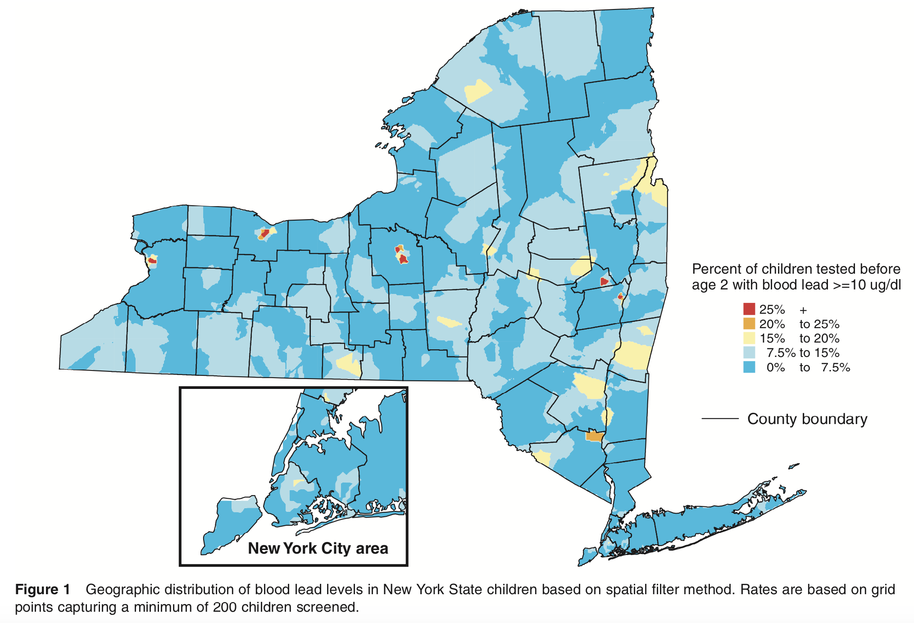

(Geographic distribution of blood lead levels in New York State children based on spatial filter method, Talbot et al)

According to the EPA, professional lead-based paint removal cost about $8 to $15 per square foot or about $9,600 to $30,000 for a 1,200- to 2,000-sq. ft. house. The average removal project costs about $10,000 [17].

The city of Portland has a Lead Abatement Program [12] that we utilized as our model.

We propose the New York State Lead Abatement Program be a program that offers the following to aid with lead abatement.

1. Lead inspections and Healthy Homes assessments
2. Forgivable loans up to $10,000 for each unit in the property to address lead hazards
3. Technical advice from city lead specialists
4. Assistance with relocation during construction
5. Grant assistance to address health & safety hazards.

An economic analysis conducted in the United States found the current costs of childhood lead poisoning to be US$ 43 billion per year [18]. A recent cost–benefit analysis undertaken in the United States found that for every US$ 1 spent to reduce lead hazards, there is a benefit of US$ 17–220. This cost–benefit ratio is better than that for vaccines, which have long been described as the single most cost-beneficial medical or public health intervention [18].

We propose New York State to fund, in part, the New York State lead abatement program utilizing state funds and to require insurance companies providing insurance to New Yorkers to pay the remainder for lead abatement activities. Given the cost benefit ratio, Insurance companies are likely to accommodate paying for lead abatement activities (primary and secondary prevention) thereby reducing the amount they would have to pay for tertiary prevention.

**3.8 Residential property lead-based paint hazard abatement revolving loan fund**

As proposed in the New York State Assembly bill 3432, we support the creation of a residential property lead-based paint hazard abatement revolving loan fund.

The fund shall consist of proceeds received from the sale of bonds and any sums that the state may from time to time deem appropriate, as well as donations, gift, bequests, or otherwise from any public or private source, which money is intended to assist owners of residential properties in meeting the standards for either lead free or lead contained certification [19].

Funds places in the residential property lead-based paint hazard abatement revolving loan fund shall be made available, at the discretion of the deputy commissioner of health, to the owners of affected properties including those located within municipalities of more than one million inhabitants, and to non-profit organizations for the purpose of bringing affected properties into compliance with the standards for lead-free, lead-contained, or lead-stabilized property status [19].

Loans made available under the provisions of this section maybe made directly, or in cooperation with other public and private lenders, or any agency, department, or bureau of the federal government or the state.

The proceed from the repayment of any loans made for that purpose shall be deposited in and returned to the residential property lead abatement revolving loan fund to constitute a continuing revolving fund for the purposes provided.

**3.9 Lead-safe housing registry as a resource to Renters**

We propose the development of a registry of housing units that have been deemed lead-safe by a licensed New York State risk assessor. We propose this ‘Lead Safe Housing Registry’ as a resource, which would help renters stay informed about prospective housing units.

We propose this registry have the following information

1- Address of property (house number, road, city and postcode)

2- If the premises have been inspected by a licensed New York State risk assessor

3- If yes to question 2, the date the assessment was done, name of assessor, assessor license and work address

4- Summary of assessment results

5- Was lead abatement performed?

6- If yes, to question 5, name and work address of contractor

Alternatively, we recommend New York State to include the above information in the New York State, housing search engine at [NYHousingSearch.gov](http://NYHousingSearch.gov)

Support for the ‘lead-safe housing registry as a resource to renters’ will be presented as an option only after consideration and deliberation with NYSAC and several county attorneys.

**3.10 Regulation of online rental marketplace listings**

Web-based real estate and rental marketplaces account a significant market share of rental transactions/agreements and are a popular resource for prospective renter.

We propose the state request and require online rental marketplaces to expressly inform potential renters if the listing is lead safe. This could be expanded, by 2025, to ensure all rental listings on online websites are lead safe.

Support for the ‘regulation of online rental marketplace listings’ will be presented as an option only after consideration and deliberation with NYSAC and several county attorneys.

**Utilizing the options provided in this proposal will help raise enough revenue to help fund the current existing expanded mandate.**

|  |  |
| --- | --- |
| Funding option | Revenue |
| Utilizing Health Care Reform Act (HCRA) Resources | Dependent on state budget allocation |
| Utilizing General Fund Resources | Dependent on state budget allocation |
| Lead poisoning prevention fee on paint  Fee set at- $0.50 per gallon  $0.75 per gallon  $1.0 per gallon | $19,500,000  $29,250,000  $39,000,000 |
| Surcharge fee on Homeowners’ Insurance and Renters’ Insurance | $56,500,000 |
| Utilizing Master Settlement Agreement (MSA) funds for secondary and tertiary prevention | Dependent on state budget allocation |
| New York State Lead Abatement Program | Dependent of state budget allocation |

NYSACHO would like to take the opportunity to recognize and commend the efforts of the New York State legislature and governor for their action and dedication to protect New York’s children.

We hope the recommendations and proposals presented in this paper are utilized to help fund the mandate, thereby heralding New York State as a leader in lead paint remediation efforts in our nation.

NYSACHO have and will remain at the service of all Local Health Departments and the state and look forward to collaborating with the legislature and the governor’s office to help bridge the gap that will ensure comprehensive implementation of the expanded mandate.

**4.1 References**

1. World Health Organization, ‘Lead poisoning and health’ 2018. Retrieved from <https://www.who.int/news-room/fact-sheets/detail/lead-poisoning-and-health>. Accessed on July 10th, 2019
2. New York State Department of Health, ‘Sources of Lead’ 2018. Retrieved from <https://www.health.ny.gov/environmental/lead/sources.htm>. Accessed on July 11th, 2019.
3. Centers for Disease Control and Prevention, ‘Prevention tips’ 2014. Retrieved from <https://www.cdc.gov/nceh/lead/tips.htm>. Accessed on July 12th, 2019.
4. New York State Department of Health Lead Poisoning Prevention program, 2009. Guidelines for follow-up of children with elevated blood lead levels for local health department lead poisoning prevention programs. Retrieved from <https://www.health.ny.gov/environmental/lead/docs/2009-08_guidelines_lhu_children_elevated_blood_lead.pdf>. Accessed on July 21st, 2019.
5. United States Census Bureau, 2013-2017 American Community Survey 5-Year Estimates, Retrieved from <https://factfinder.census.gov/faces/tableservices/jsf/pages/productview.xhtml?src=bkmk>, accessed on July 13th 2019
6. New York State Department of Health Housing Units Built before 1950 designated by 2000 US Census. Retrieved from [https://apps.health.ny.gov/statistics/environmental/public_health_tracking/tracker/index.html#/childhoodLeadOlderHousingTable](https://apps.health.ny.gov/statistics/environmental/public_health_tracking/tracker/index.html%23/childhoodLeadOlderHousingTable). Accessed on July 13th, 2019.
7. Maine Department of Health and Human Services, Frequently asked questions on the lead poisoning prevention fee. Retrieved from <https://www.maine.gov/dhhs/mecdc/environmental-health/eohp/lead/documents/LPPF_PaintFee_FAQ.pdf>. Accessed on July 16th, 2019.
8. Maine Legislature. Section 1322-F Lead poisoning prevention fee. Retrieved from <https://legislature.maine.gov/statutes/22/title22sec1322-F.html>. Accessed on July 16th, 2019.
9. New York Product Stewardship Council. Save Money and Create Jobs in New York. Retrieved from <http://nypsc.org/wp-content/uploads/2017/03/2017.01.12_NY-Paint-Fact-Sheet_FNL.pdf>. Accessed on July 16th, 2019.
10. Insurance Information Institute. Number of Renters is on the rise- but few of them have insurance. Retrieved from <https://www.iii.org/press-release/number-of-renters-is-on-the-rise-but-few-of-them-have-insurance-092214>. Accessed on July 16th, 2019.
11. Public Health Law Center 2018. The Master Settlement Agreement: An Overview. Retrieved from <https://publichealthlawcenter.org/sites/default/files/resources/MSA-Overview-2018.pdf> Accessed on July 18th 2019.
12. City of Portland website 2019. Lead Safe Housing and Healthy Homes. Retrieved from <https://www.portlandmaine.gov/1902/Lead-Safe-Housing>. Accessed on July 20th.
13. United States Government Accountability Office 2007. Tobacco Settlement, States’ Allocations of payments from tobacco companies for fiscal years 2000 through 2005. Retrieved from <https://www.gao.gov/assets/120/115580.pdf>. Accessed on July 20th, 2019.
14. Campaign for Tobacco-Free Kids 2019. Actual annual tobacco settlement payments received by the states, 1998-2019. Retrieved from <https://www.tobaccofreekids.org/assets/factsheets/0365.pdf>. Accessed on July 20th, 2019.
15. Henry J Kaiser Family Foundation 2019. Actual Tobacco Settlement Payments received by the States. Retrieved from <https://www.kff.org/health-costs/state-indicator/tobacco-setlmentpaments/?currentTimeframe=0&sortModel=%7B%22colId%22:%22Location%22,%22sort%22:%22asc%22%7D>. Accessed on 21st July 2019.
16. T Talbot, S Forand and V Haley. Geographic Analysis of Childhood Lead Exposure in New York State. Geographic Research and Analysis Section, Bureau of Environmental and Occupational Epidemiology, New York State Department of Health, Troy, NY. Retrieved from <https://pdfs.semanticscholar.org/bee0/bc5d8852702844976ec81d9a8e1814775370.pdf>Accessed on July 21st, 2019.
17. Houselogic by realtors. Lead Paint Removal: How To, Options, and Costs. Retrieved from <https://www.houselogic.com/remodel/painting-lighting/lead-paint-removal/>. Accessed on July 21st, 2019.
18. World Health Organization 2010. Childhood Lead Poisoning. ISBN 978 92 4 150033 3. Retrieved from <https://www.who.int/ceh/publications/leadguidance.pdf>. Accessed on July 21st, 2019.
19. State of New York, Assembly bill 3432. 2019-2020 Regular Session, introduced January 29th 2019. Retrieved from Legislative Retrieval System. Accessed on July 21st 2019.
20. [Independent Budget Office of the City of New York](https://ibo.nyc.ny.us/index.html), 2019. Health Care Reform Act of 2000: An Overview. Retrieved from <https://ibo.nyc.ny.us/newsfax/nws58healthreform.html>. Accessed on August 14th2019
21. State of New York, Senate-Assembly Budget Bill S.1500—D A.2000—D, January 15th 2019. Retrieved from Legislative Retrieval System. Accessed in January 2019.
22. Open Budget, 2019. New York State Website. Retrieved from <https://openbudget.ny.gov/userGuide.html>. Accessed on August 13th 2019.
23. Division of the Budget, 2019. FY 2020 Enacted Budget Financial Plan. Retrieved from <https://www.budget.ny.gov/pubs/archive/fy20/enac/fy20fp-en.pdf>. Accessed on August 13th 2019.